**Topic 10**

**Organic Chemistry SL**

**10.1 Fundamentals of organic chemistry**

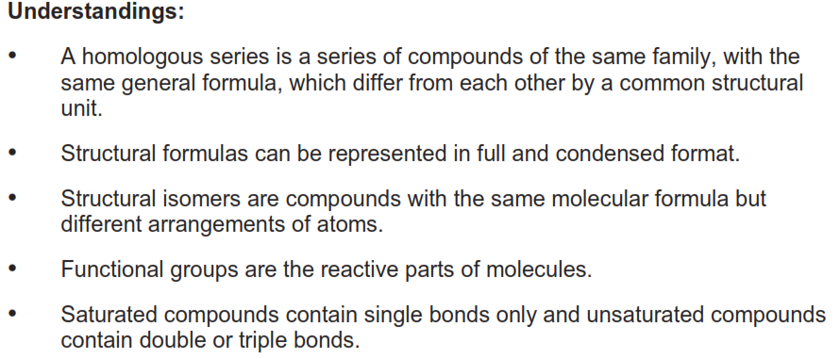

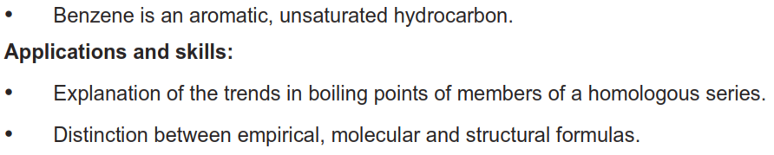

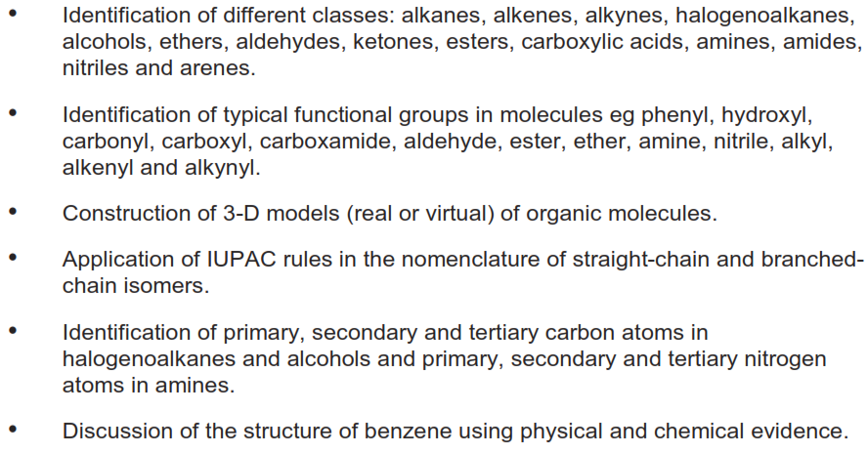

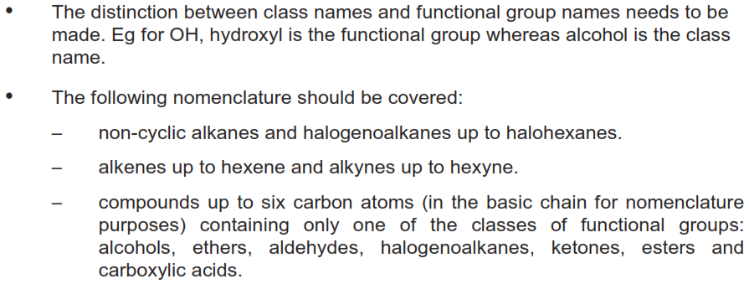

**10.2 Functional group chemistry**

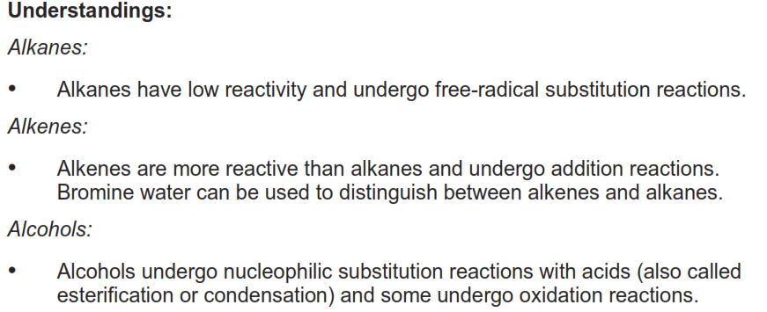

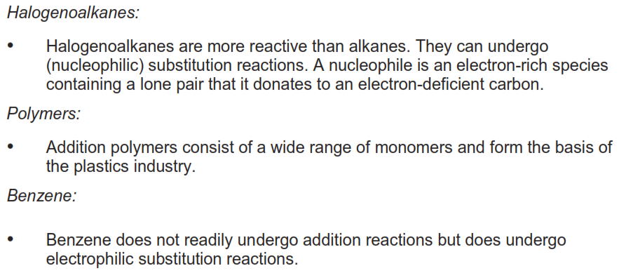

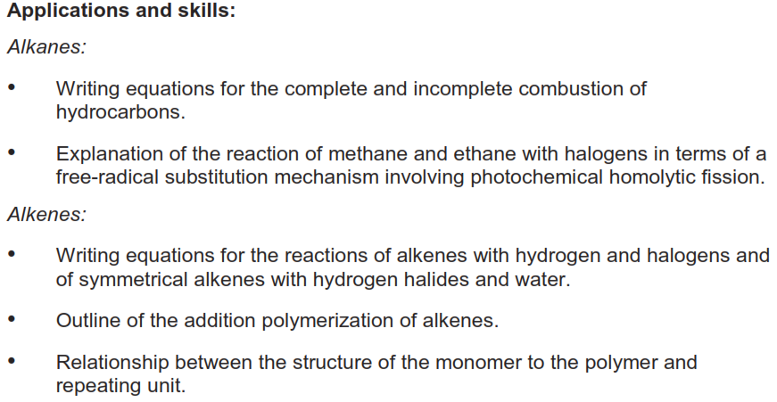

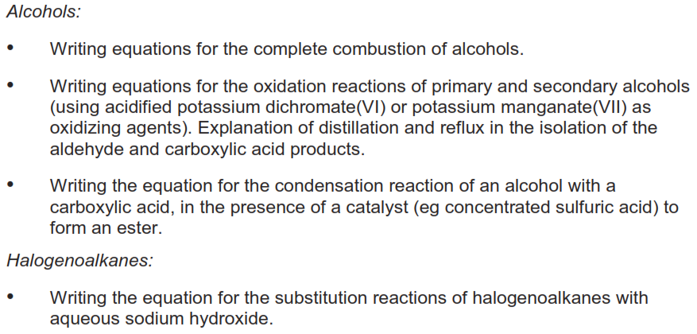

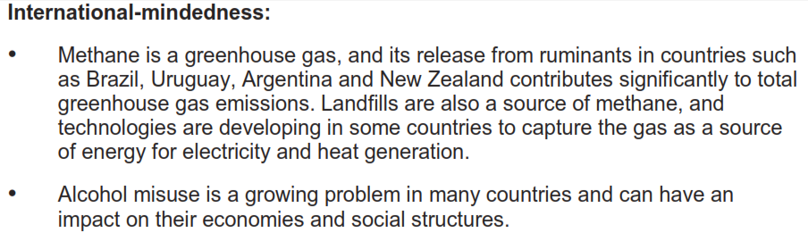

**Homologous series**

* A homologous series is a series of organic compounds of the same family which differ by a common structural unit.



* Functional group: hydroxyl (OH) – each member differs by CH2
* Members of a homologous series have similar chemical properties.



* They also show a gradation in physical properties (such as the increasing boiling point of the alkanes).

###### Summary:

Members of a homologous series:

* differ by a CH2
* have the same general formula
* have similar chemical properties
* show a gradation (gradual increase) in physical properties such as boiling point

**Structural formulae**

|  |  |  |  |  |  |
| --- | --- | --- | --- | --- | --- |
| **Compound** | **Molecular formula** | **Empirical formula** | **Full structural formula** | **Condensed structural formula** | **Skeletal formula** |
| butane | C4H10 | C2H5 |  | CH3(CH2)2CH3 |  |
| but-1-ene | C2H8 | CH2 |  | CH2CHCH2CH3 |  |
| hex-2-yne | C6H10 | C3H5 |  | CH3CCCH2CH2CH3 |  |

**Skeletal formulae**

 

  

**Stereochemical formulae**



* The two solid lines are in the plane of the paper.
* The wedge is coming out from the plane of the paper.
* The dashed line is going into the plane of the paper.

**Functional groups**

* A functional group is a group of atoms within a molecule that are responsible for the characteristic chemical reactions of the molecule.



Class: alcohols

Functional group: hydroxyl group

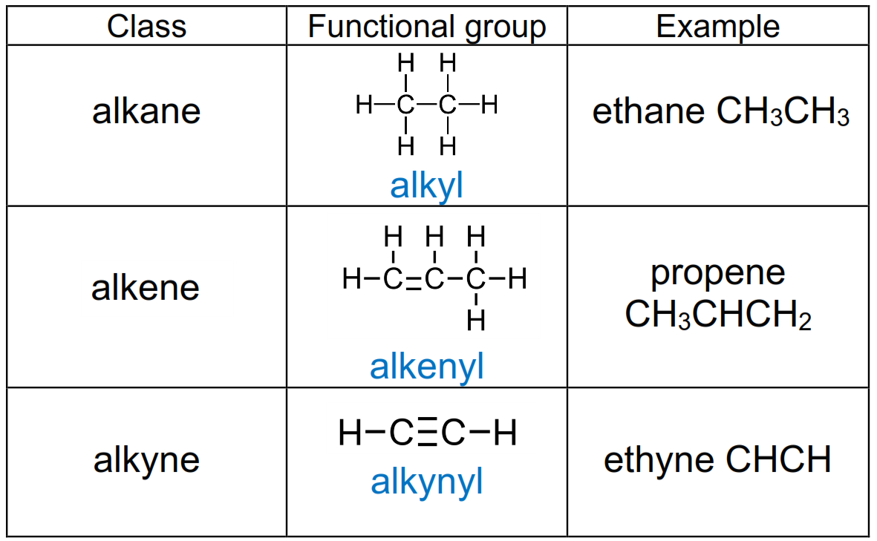

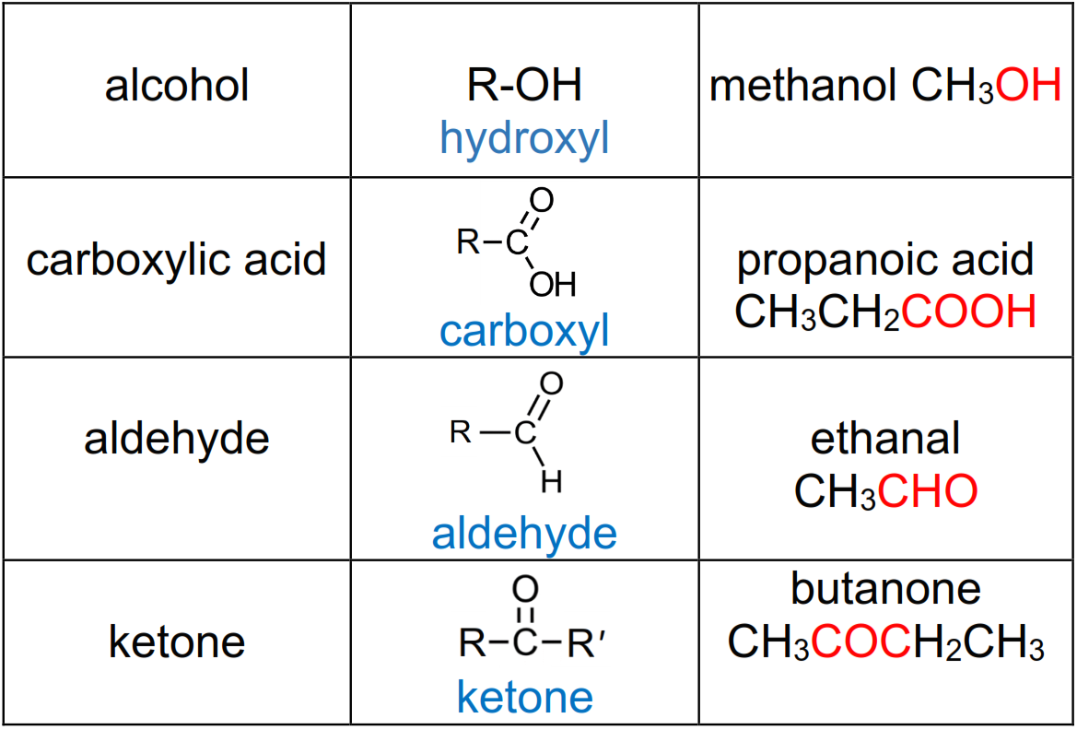

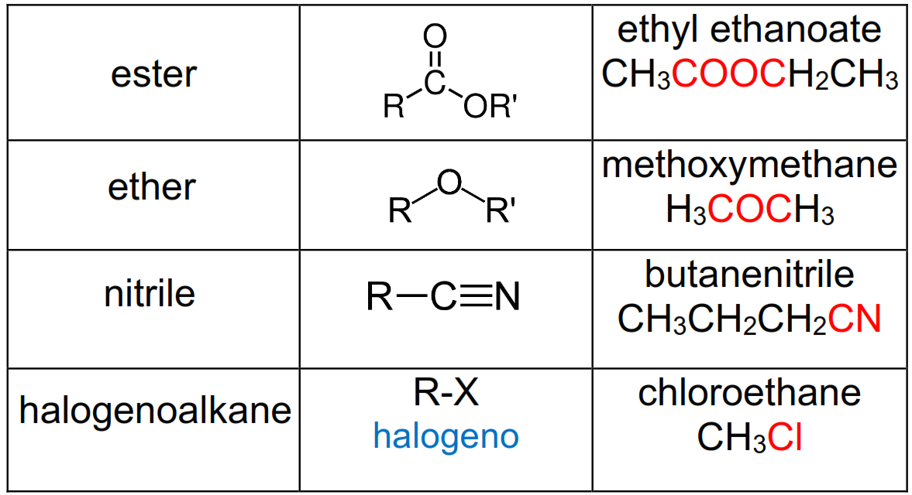

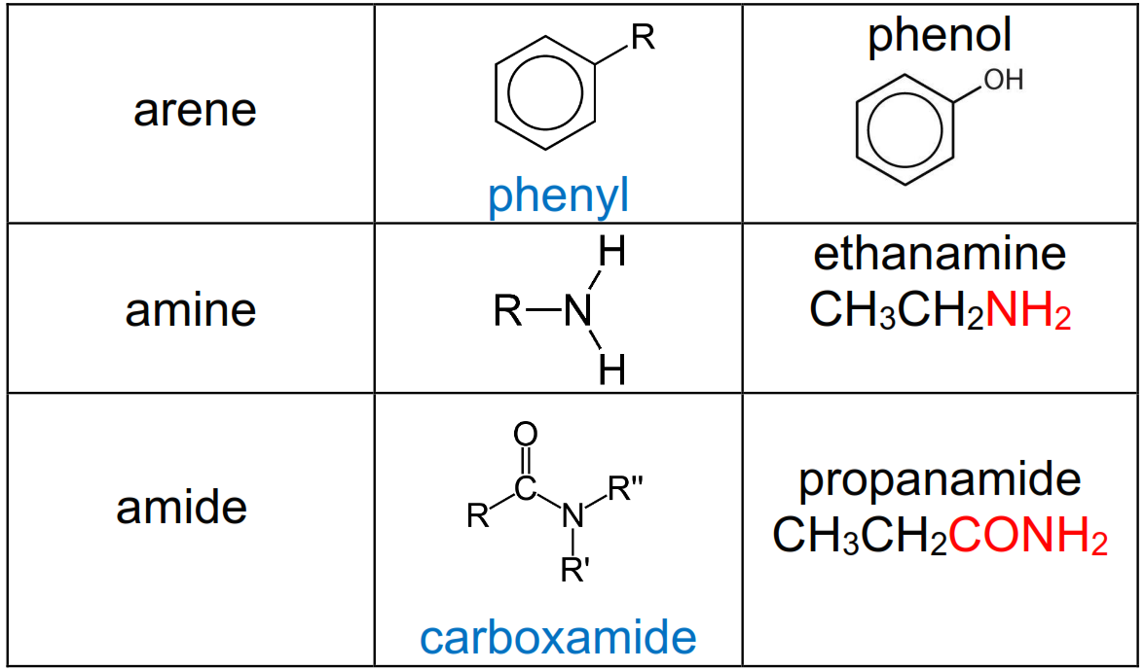

**Exercise**: For each of the following organic compounds, state the class and functional group.

|  |  |
| --- | --- |
|  |  |
|  |  |
|  |  |
|  |  |
|  |  |
|  |  |
|  |  |

**Naming organic compounds**

* Students are required to name organic compounds with up to 6 carbon atoms.

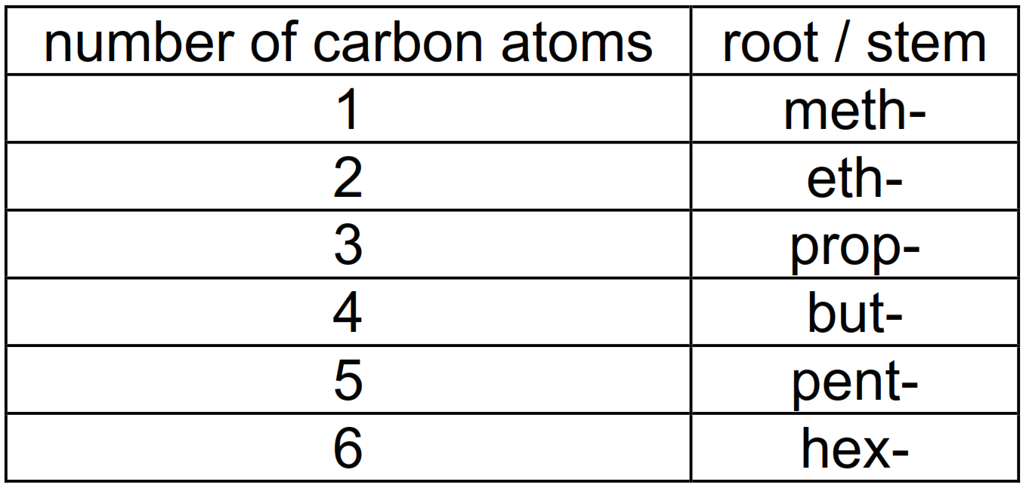

**Alkanes**

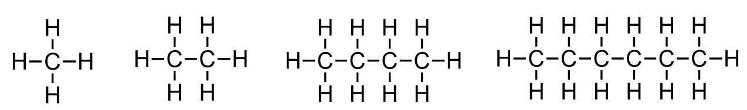

* General formula CnH2n+2
* Alkanes are saturated hydrocarbons (C-C single bonds)

**Alkenes**

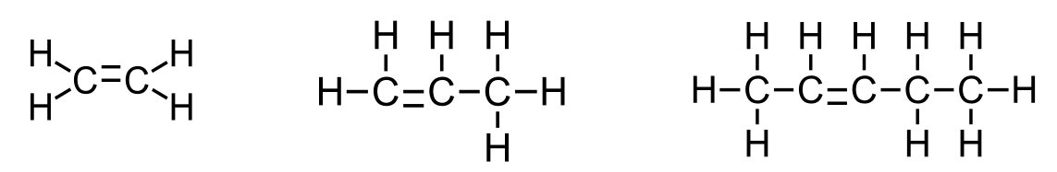

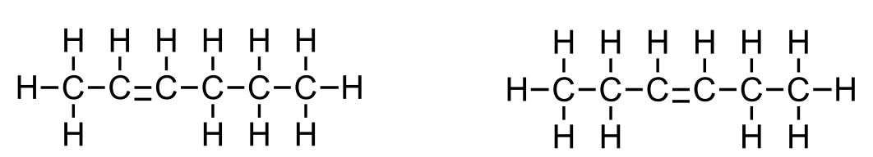

* General formula CnH2n
* Alkenes are unsaturated hydrocarbons (C=C double bond)

**Alkynes**

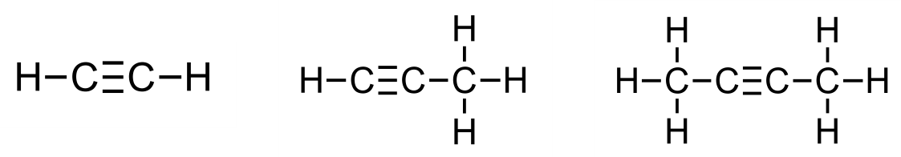

* General formula CnH2n-2
* Alkynes are unsaturated hydrocarbons (C to C triple bond)

**Alcohols**

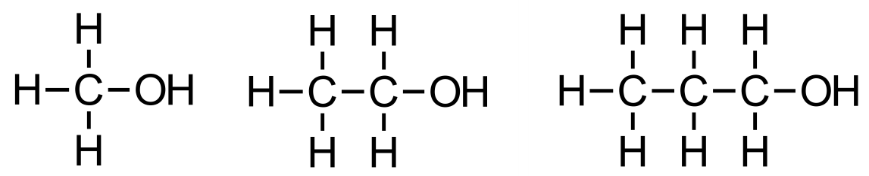

* General formula CnH2n+1OH

**Carboxylic acids**

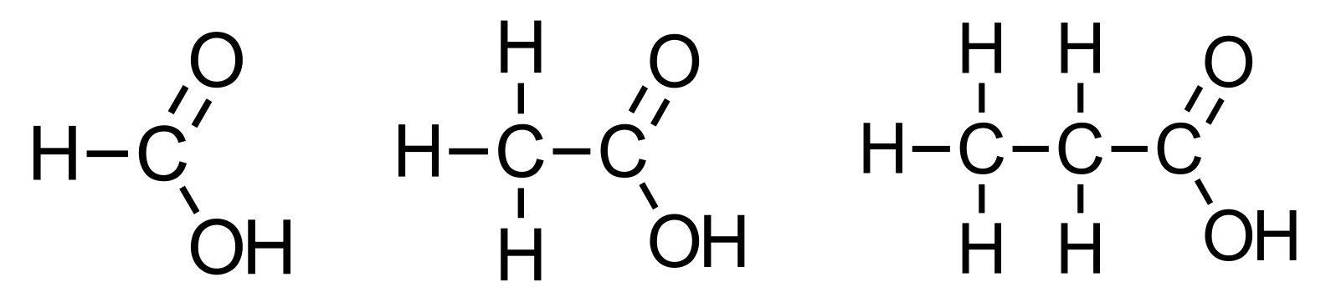

* General formula CnH2n+1COOH

**Aldehydes**

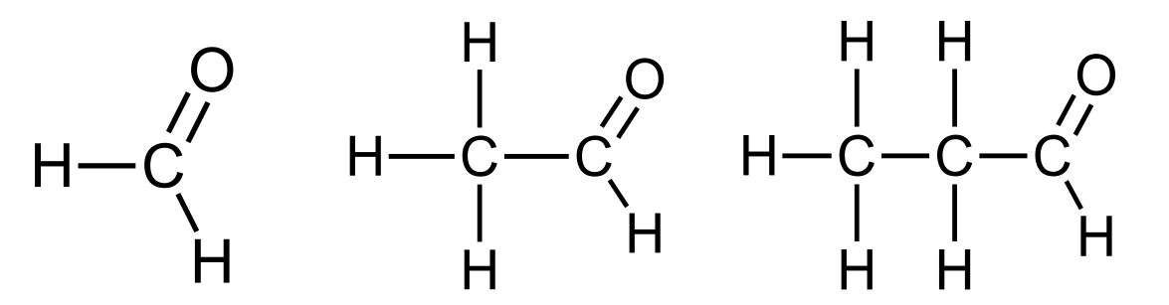

**Ketones**

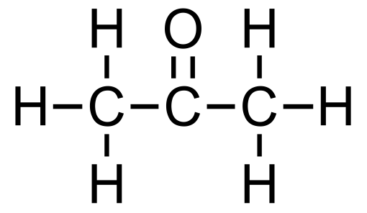 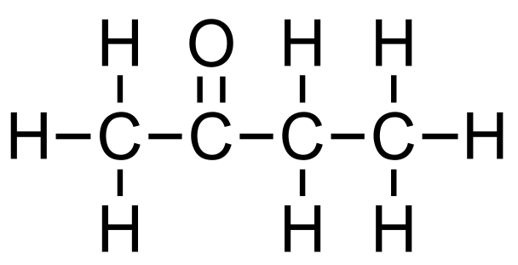 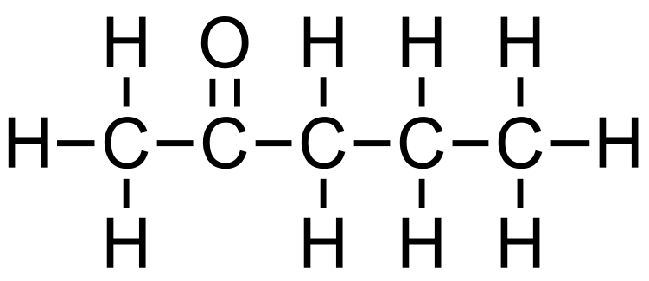

**Halogenoalkanes**

* Halogenoalkanes contain an atom of fluorine, chlorine, bromine or iodine.
* General formula CnH2n+1X

  

**Amines**

* Amines are derivatives of ammonia, wherein one or more hydrogen atoms have been replaced by a substituent such as an alkyl or aryl group.

**  **

**Branched alkanes**











**Structural isomers**

* Structural isomers are compounds with the same molecular formula but different arrangements of atoms.

Structural isomers of C5H12

 



**Classification of organic compounds**

* Alcohols and halogenoalkanes can be classified as primary, secondary or tertiary depending on how many carbons atoms are bonded to the carbon atom that is bonded directly to the functional group.

  

**Exercises:**

1) Name classify the following alcohols as primary, secondary or tertiary:

  

2) Name and classify the following halogenoalkanes as primary, secondary or tertiary:

  

3) Name and classify the following amines as primary, secondary or tertiary:

  

**Benzene**

* Benzene is an aromatic unsaturated hydrocarbon
* Molecular formula C6H6
* Empirical formula CH

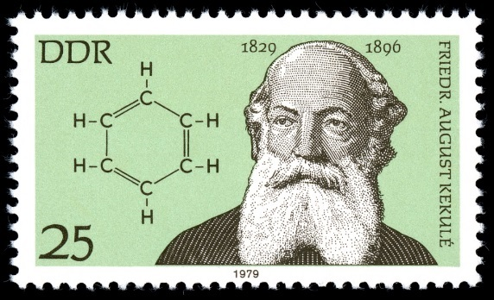

In 1865 Friedrich August Kekulé suggested that benzene contained a ring of six carbon atoms with alternating single and double bonds.



* The Kekulé structure of benzene consists of alternating single and double bonds.

** **

** **

**How do we know that the structure of benzene does not consist of alternating single and double bonds?**

1. **The length of the strength of the C to C bonds**

* The C to C bonds are of identical length and strength.
* The length and strength of the C to C bonds in benzene are intermediate between a single and a double bond.

1. **The enthalpy of hydrogenation of benzene is less than predicted**

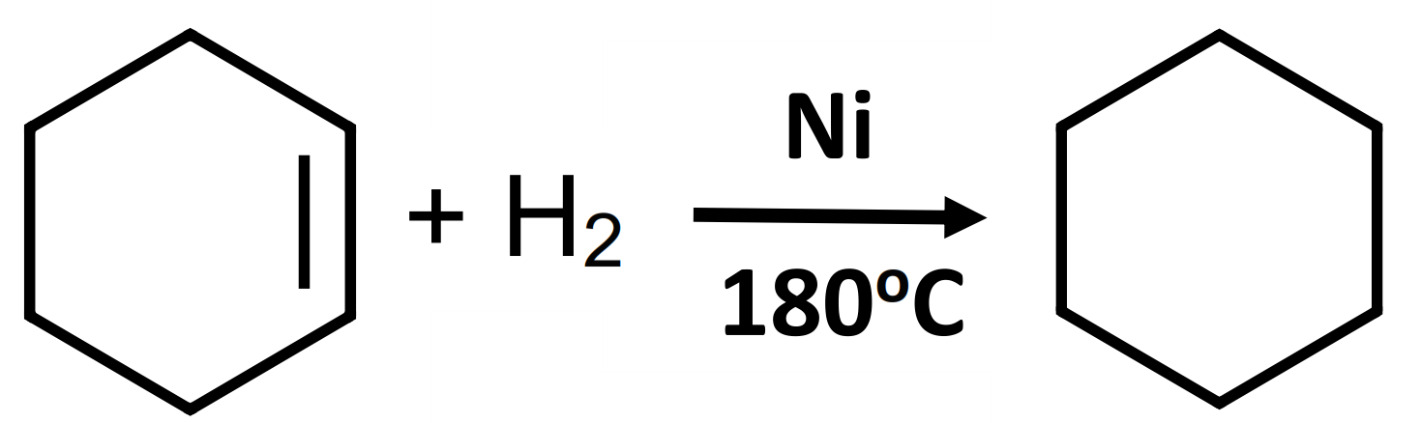

ΔH = - 120 kJ mol-1

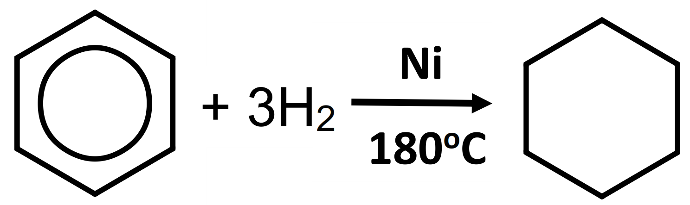

ΔH = - 210 kJ mol-1

* Delocalization of π electrons minimizes the repulsion between the electrons, lowering the internal energy by 150 kJmol-1 (resonance energy).

1. **Benzene undergoes substitution reactions, rather than addition reactions.**

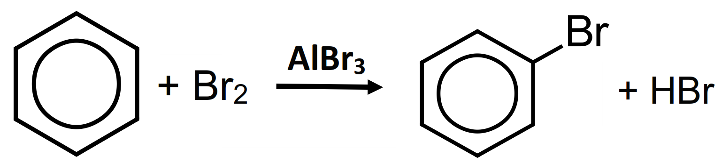

**The actual structure of benzene**

* Benzene has delocalised π electrons in the pi bond region.

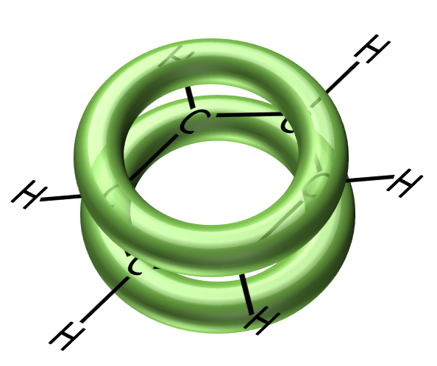

**π bonded region**

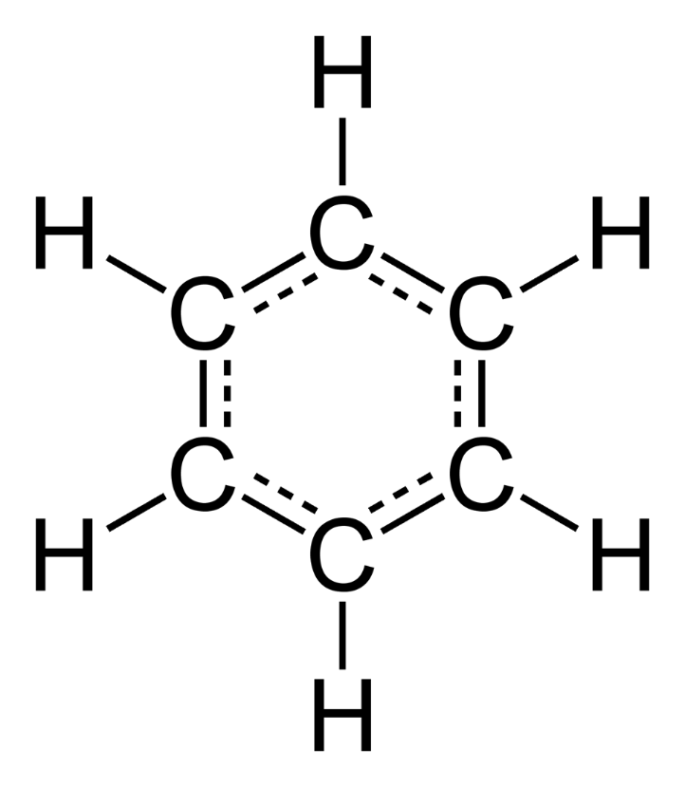 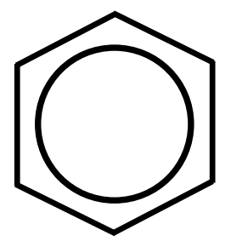

* Each carbon to carbon bond is intermediate in strength between a single and a double bond.

**Factors that affect the boiling points of organic compounds**

**Molar mass and boiling point**

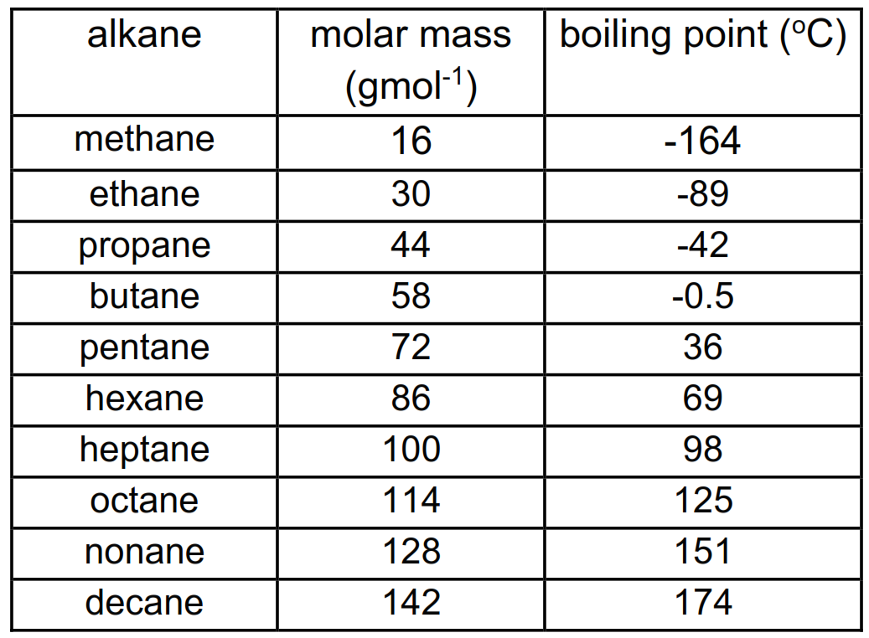

* As the molar mass of the compound increases, the boiling point increases.
* As the molar mass increases, the strength of the London dispersion forces between the molecules increases (the molecules have more electrons and are more easily polarizable).
* More energy is required to overcome the London dispersion forces between the molecules, therefore the boiling point increases.

**Branched isomers vs straight chain isomers**

* Branched isomers have lower boiling points than straight chain isomers.
* The branches prevent the molecules getting close together which reduces the strength of the London dispersion forces and lowers the boiling point.

**Effect of functional group**

** **

* Compounds with functional group containing H bonded to O or N have hydrogen bonding between molecules.
* Compounds with functional group containing carbonyl group (C=O) have dipole-dipole forces between molecules.
* Alcohols, amides and carboxylic acids have higher boiling points as they are able to form hydrogen bonds between molecules.
* Aldehydes, ketones, and esters have dipole-dipole forces between molecules.
* Alkanes, alkenes and alkynes have London dispersion forces between molecules.

**low volatility**

**Increasing boiling point**

**high volatility**

**Amides**

**Carboxylic acids**

**Alcohols**

**Ketones**

**Aldehydes**

**Esters**

**Alkanes**

**Exercises:**

1. Methane and heptane belong to the same class (the alkanes). Predict and explain which compound has a higher boiling point.
2. Explain the difference in boiling point between the structural isomers propane and 2-methylbutane.
3. Ethanol and propane have similar molar masses but different boiling points. Predict and explain which compound has the highest boiling point.

**Reactions of the alkanes**

* Alkanes have low reactivity for two reasons:

1. the C-H bond is a non-polar bond

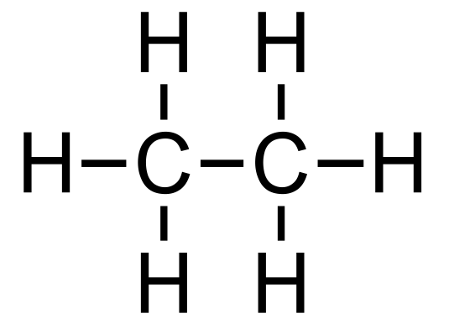

1. the C-C and C-H bonds are strong (C-C 348 kJ mol-1 C-H 412 kJ mol-1)

**Alkanes undergo combustion reactions**

* Complete combustion



* Incomplete combustion





**Alkanes undergo free-radical substitution reactions**

Initiation – occurs in the presence of UV light

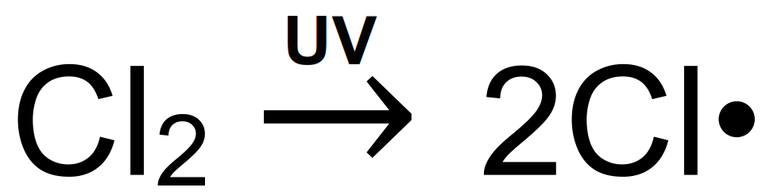

* Photochemical homolytic fission – the bond between the chlorine atoms is split by UV light with each chlorine atom taking one electron from the single bond.

Propagation – keeps the reaction going

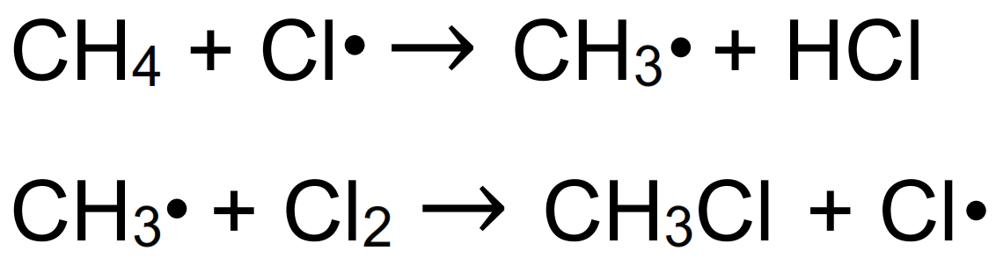

Termination – ends the reaction

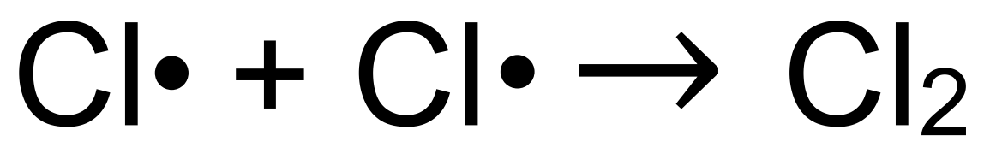

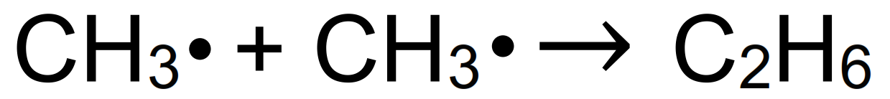

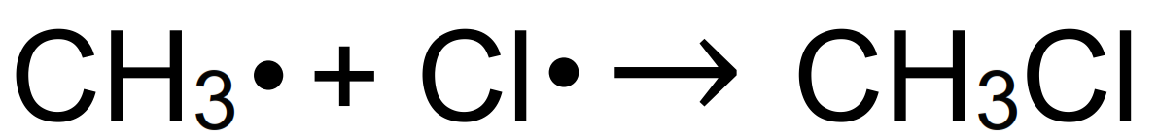

Overall equation:

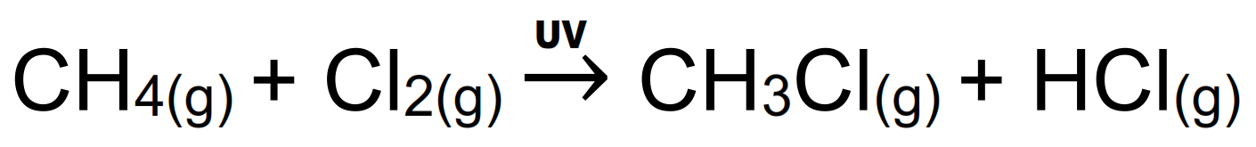

**Exercise:**

Ethane reacts with bromine to form bromoethane in a free-radical substitution reaction. Write initiation, propagation and termination steps for the reaction.

**Reactions of the alkenes**

* Alkenes undergo addition reactions.
* Alkenes are reactive as the π bond is easily broken to form two new bonding positions.

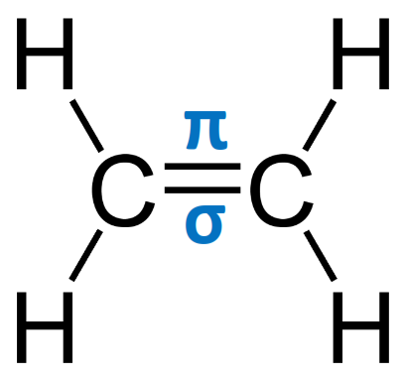

**Hydrogenation**

* Alkenes react with hydrogen in the presence of a nickel catalyst at a temperature of 150oC to form alkanes.

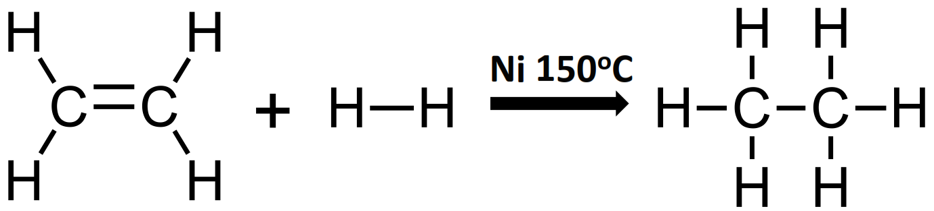

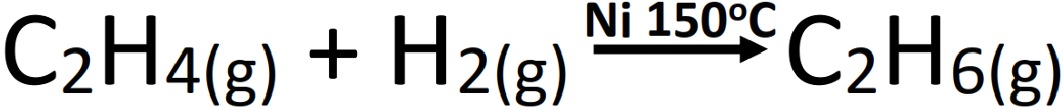

**Halogenation**

* Alkenes react with halogens to produce dihalogeno compounds.

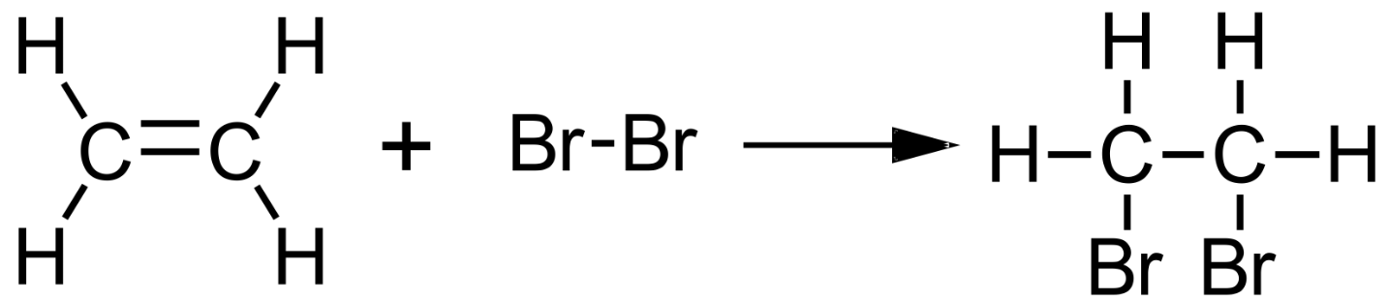



* The colour change in this reaction is brown to colourless (the bromine water is decolourised).
* This colour change indicates the presence of carbon to carbon double bonds (unsaturation).
* Alkenes react with hydrogen halides (HCl, HBr and HI) to produce halogenoalkanes.

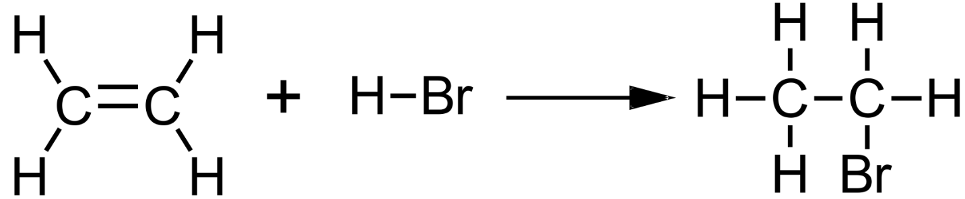



**Hydration**

* Alkenes react with steam in the presence of a sulfuric acid catalyst to form alcohols.

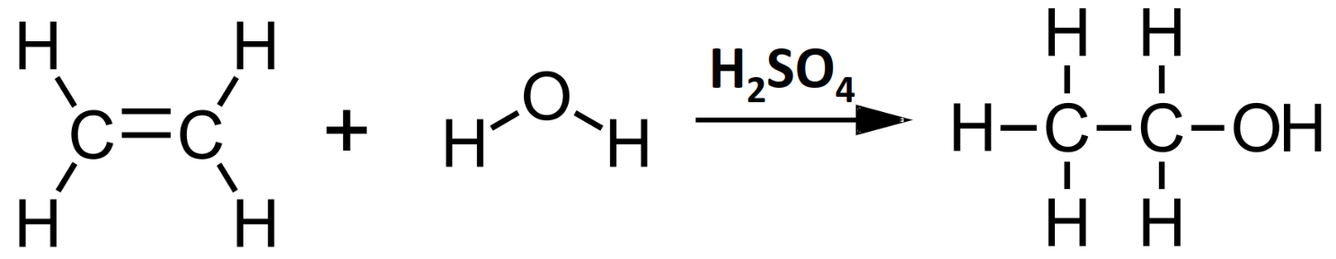



**Addition polymerization**

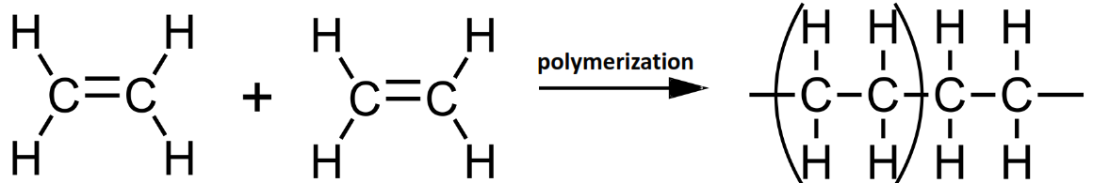

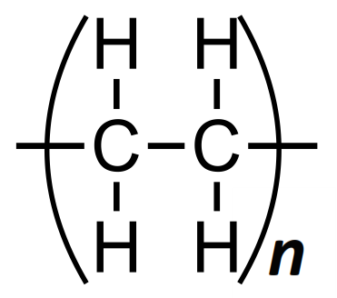

**Reactions of the alcohols**

* Alcohols undergo combustion in excess oxygen (complete combustion) to form carbon dioxide and water.

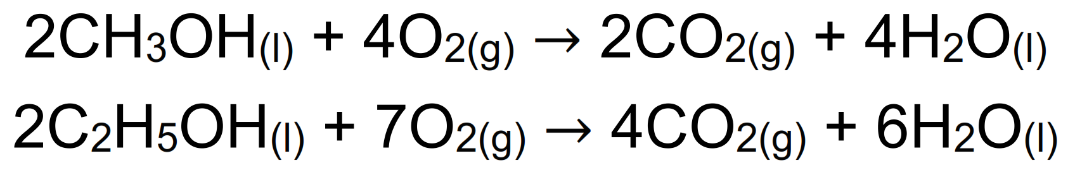

**Oxidation reactions of the alcohols**

* Primary alcohols are oxidized by acidified potassium dichromate(VI) (Cr2O72-/H+) and heat to form aldehydes or carboxylic acids.

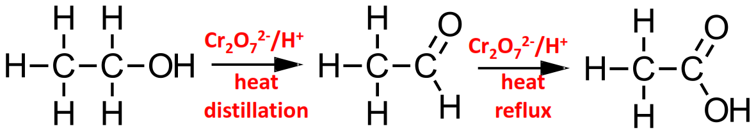

* Colour change orange to green (Cr2O72- ion is reduced to the Cr3+ ion)
* Secondary alcohols are oxidized by acidified potassium dichromate(VI) (Cr2O72-/H+) and heat to form ketones

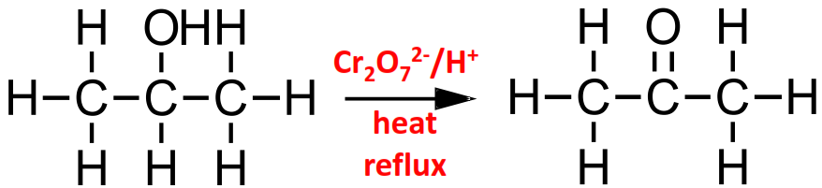

* Colour change orange to green (Cr2O72- ion is reduced to the Cr3+ ion)
* Tertiary alcohols cannot be oxidized by acidified potassium dichromate(VI) (Cr2O72-/H+) (no H atoms bonded directly to C-OH)

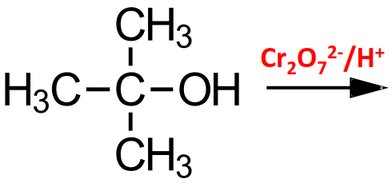

**No reaction, (no colour change).**

**Esters**

* Alcohols and carboxylic acids react to form esters.
* This is a nucleophilic substitution reaction (it is also called a condensation or esterification reaction).
* The catalyst is concentrated sulfuric acid (conc. H2SO4).



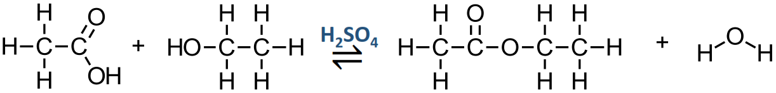



* Esters have distinctive fruity smells.
* Esters are used as natural and artificial food flavorings.
* They are also used as solvents in perfumes and as plasticizers.

**Naming esters**













**Reactions of halogenoalkanes**

* General formula CnH2n+1X
* Halogenoalkanes contain an atom of fluorine, chlorine, bromine or iodine.

**  **

* Halogenoalkanes undergo substitution nucleophilic reactions (the replacement of one atom by another atom or group).



The halogen is more electronegative than the carbon atom forming a polar bond.

The halogen has a partial negative charge and the carbon has a partial positive charge (electron deficient).

* Nucleophiles are electron rich species that contain a lone pair of electrons that it donates to an electron deficient carbon.

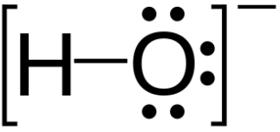 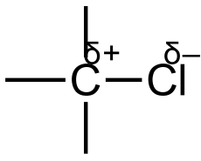

* The hydroxide ion (nucleophile) is attracted to the electron deficient carbon in the halogenoalkane.



**+**



* The conditions are warm with aqueous NaOH.

**Reactions of benzene**

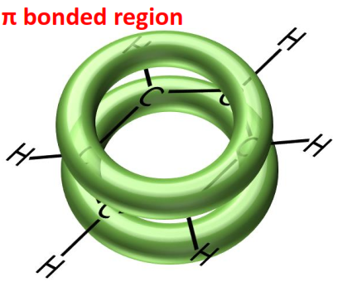

The delocalized π electrons give benzene extra stability, therefore it does not undergo addition reactions.

* Benzene undergoes electrophilic substitution reactions in which a hydrogen atom is replaced by an incoming group.



* An electrophile is a reactant which is electron deficient (has a partial positive charge).
* The electrophile is attracted to the electron rich benzene ring.

**Reaction with chlorine (Cl2)**





**Reaction with nitric acid (HNO3)**



